SMIT Core Values
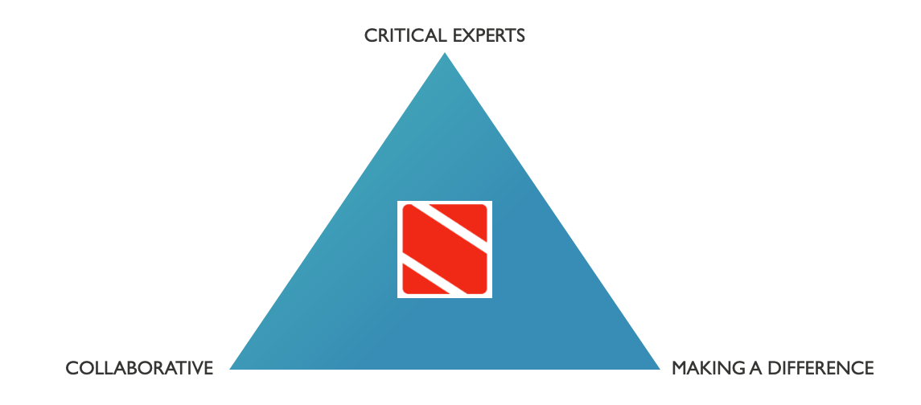

- Collaborative

A1. We actively set up networks and engage in collaborations while safeguarding our core values
A2. We share our knowledge and expertise internally to deepen and strengthen our knowledge domains and actively cooperate to create opportunities for each other
A3. We take important decisions together at the relevant decision making level (staff, unit,…) and propagate them consequently

- Critical experts

B1. We are knowledgeable in the relevant developments, methods, theories and authors in our discipline and keep an eye on innovations in our field
B2. We are constructively critical: based on our scientific expertise we ask questions, offer explanations and seek solutions
B3. We aim high and together make SMIT into a centre of reference

- Making a difference

C1. We share our scientific expertise broadly in order to be visible with academia, stakeholders, government and a wide audience
C2. We prioritise projects according to their societal and scientific relevance
C3. We translate scientific knowledge into applicable insights, tools and recommendations

