  
**STAR**  
**S**upport **T**raining **A**ctivities on the data protection **R**eform  
project-star.eu

**Dissemination report**

Deliverable **D5.5**

 version 1.0

**Renáta Nagy, Gábor Kulitsán**

Brussels – London – Budapest  
**November 2019**

distribution level: **confidential**

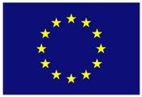

**A report prepared for the European Commission’s Directorate-General for Justice and Consumers (DG JUST).**

The STAR project (*Support Training Activities on the data protection Reform*; 2017-2019) is co-funded by the European Union under the Rights, Equality and Citizenship Programme 2014-2020 (REC-RDAT-TRAI-AG-2016) under Grant Agreement No. 769138.

The contents of this deliverable are the sole responsibility of the authors and can in no way be taken to reflect the views of the European Commission.

Source of the picture on the cover page: <https://incontinence.cochrane.org/sites/incontinence.cochrane.org/files/public/uploads/social_network.jpg>

Permanent link:  
[N/A](https://projectstareu.files.wordpress.com/2019/06/star-d4.1-web-based-questionnaire.pdf)

|  |  |
| --- | --- |
| **Authors** | |
| **Name** | **Partner** |
| Renáta Nagy | NAIH |
| Gábor Kulitsán | NAIH |

|  |  |
| --- | --- |
| **Contributors** | |
| **Name** | **Partner** |
| Júlia Sziklay | NAIH |
| David Barnard-Wills | TRI |

|  |  |
| --- | --- |
| **Internal Reviewers** | |
| **Name** | **Partner** |
| István Böröcz | VUB |

|  |  |  |
| --- | --- | --- |
| **Institutional Members of the STAR Consortium** | | |
| **Member** | **Role** | **Website** |
| Vrije Universiteit Brussel (VUB) Research Group on Law, Science, Technology and Society (LSTS) | Project Coordinator | https://lsts.research.vub.be/ |
| Trilateral Research Ltd. (TRI) | Partner | trilateralresearch.com |
| Nemzeti Adatvédelmi és Információszabadság Hatóság (NAIH) | Partner | naih.hu |

**version 1.0  
08/11/2019**

Table of Contents

Background to the STAR project 4

List of Abbreviations 5

1. Introduction 6

2. Dissemination tools to spread information 6

2.1 Website 6

2.2 Twitter 8

2.3 Deliverables and reports 8

2.4 Booklet 8

2.5 Press releases 11

2.6 Journal article 12

2.7 Trade press articles 12

3. Dissemination tools to distribute the training materials 12

3.1 Participation in conferences and events 12

3.1.1 Support training activities on the data protection reform (STAR) - Final conference 13

3.1.2 41th International Conference of Data Protection and Privacy Commissioners 14

3.1.3 ICO Data Protection Practitioners Conference 14

3.2 Communication with stakeholders 16

# Background to the STAR project

The STAR project (*Support Training Activities on the data protection Reform*) will provide support to the training activities of European Union (EU) Data Protection Authorities (DPAs) and data protection officers (DPOs) on the EU data protection reform, especially the General Data Protection Regulation (GDPR). The GDPR requires these two categories of data protection actors to undertake training activities (Arts 57(1) and 39(1)(b)). Each DPA developing such materials in isolation increases the overall cost, risks undermining the harmonising effect of the GDPR and puts greater pressure on its consistency mechanisms. STAR will thus provide them with necessary and efficient training materials and resources. In particular, STAR will:

1. formulate the training topics in close cooperation with stakeholders,
2. author the actual training materials,
3. validate and test them in pilot trainings.

This output will be freely and publicly available in a digital form. STAR is directly addressed to EU DPAs and DPOs; it also offers a benefit to other privacy professionals in the EU and beyond.

STAR supports the legal obligations of DPAs and DPOs to undertake training activities and, in order to facilitate their work, will provide them with ready-made, easy-to-customise and easy-to-run training materials, easily adaptable to specific training situations. STAR will also provide to the European Data Protection Board (EDPB) the common training programmes (Art 70 GDPR). The main outputs are thus the training materials and resources themselves. While their exact format and nature will be refined in cooperation with stakeholders, the following will at least be included:

1. Training scenarios for each training category,
2. A Seminars’ Topics List, based on the training scenarios,
3. Seminar Material for each one of the seminars,
4. Webinars (selected from the Seminars’ Topics List),
5. A training Handbook,
6. A takeaway reference GDPR checklist,
7. A ten-point GDPR introductory list.

# List of Abbreviations

|  |  |
| --- | --- |
| DPA | Data Protection Authority |
| DPO | Data Protection Officer |
| STAR | Support Training Activities on the data protection Reform |
| EAB | External Advisory Board |

# Introduction

In the first phase (M1-16) of the project the main goal of the dissemination activity was to inform the public about the launch of the project and recruit sufficient DPA and DPO stakeholders to participate in the development of the training materials. In the second phase of the project (M17-24) the project communication focused on informing the end-users about the existence of the training materials and foster them to try and use the materials. In this phase the Consortium also aimed to capture the experiences of the end-users as they use the training materials and build their feedback into the development process. The dissemination strategy, presented in this deliverable comprised several tools:

* Project website;
* Several press releases;
* At least one paper for peer-reviewed journal;
* Communication with stakeholders via the partners' extensive contact lists;
* Communication with stakeholders’ representative organisations (DPOs, judges, lawyers, civil servants) both at EU and Member State level;
* Circulation of project deliverables to the External Advisory Board (EAB);
* Involving the EAB structured to help achieve even wider dissemination.

The main aim of the dissemination strategy was the following:

* Design and launch the website;
* Maintain the project’s website and social media profiles;
* Identify and contact the stakeholders;
* Promote the project to the press (trade press articles, press releases);
* Provide deliverables and reports;
* Distribution of a short GDPR flyer (booklet) based on STAR material;
* Participation in conferences and events at national and European level to raise awareness for the project.

Sustainability of the project's results is dependent upon whether DPAs and DPOs have confidence in the STAR output, taking-it up, and using in their training practices. Identification of and continued dialogue with stakeholders in WS1 created the necessary engagement with the project, whilst the set of dissemination and communication work under WS4 ensured that the work is widely known and available. The Partners will incorporate the training materials into their own training and consultancy practices, and will maintain the project’s website (hosting the material) for two years following conclusion.

# Dissemination tools to spread information

## Website

The website is operating since the launch of the project at the following link: [http://www.project-star.eu](http://www.project-star.eu/). The website is the most informative dissemination tool as it is a very effective platform to convey all information on the project to the stakeholders and all audiences interested in the STAR project. Since its launch, the website is regularly updated to reach out to all interested parties and by providing the most up to date information on the activities and results of the project the website supports to maintain the interest in project activities. The website highlights the training materials, events, results, press releases, deliverables. In 2018 the structure of the website has gone through a major update as the STAR II project (SupporT small And medium enterprises on the data protection Reform II) has received funding and it has been decided by consortium members to host the content of the project on the same website.

The structure of the website is reported in deliverable D5.1 STAR online communication tools (website, social media accounts).

Data on the views and visitors is presented in the table below:

|  |  |  |
| --- | --- | --- |
|  | Views | Visitors |
| 2018 | 869 | 331 |
| 2019 | 3048 | 1414 |

Data on the most visited posts and pages of the website is presented below:

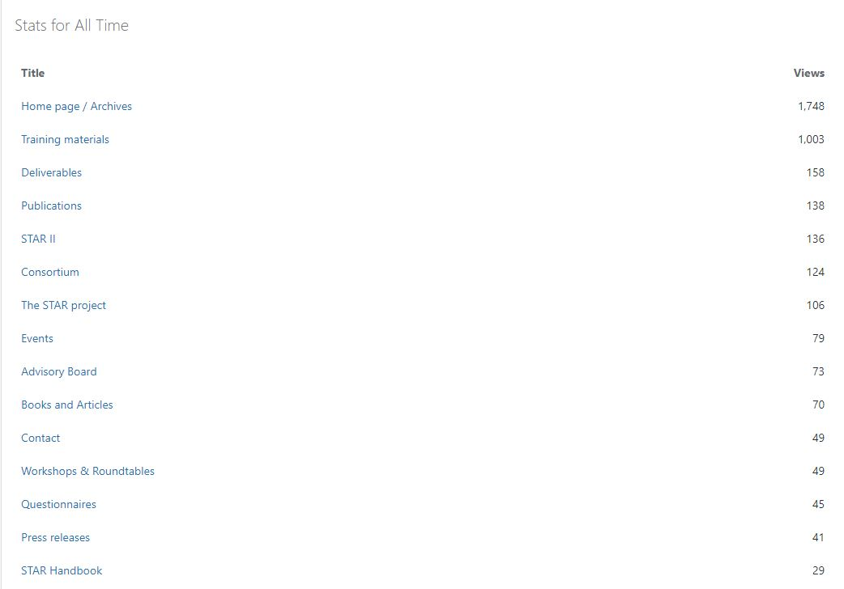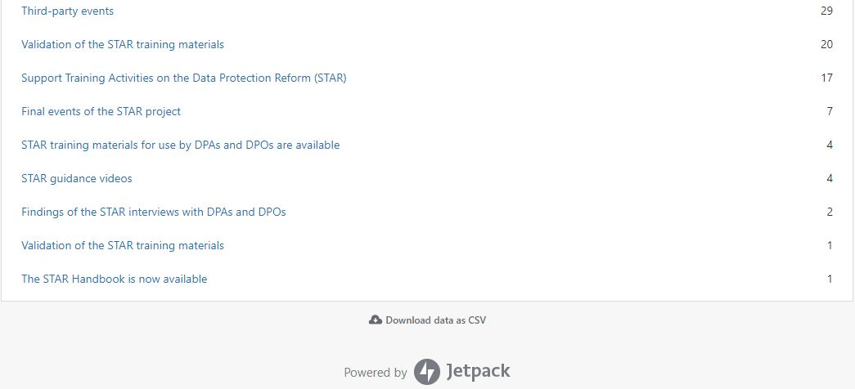

## Twitter

The Twitter account for the STAR project, @projectSTAR_eu was created in November 2017. Currently the account has 43 followers. Further information on the twitter account can be found in deliverable D5.1 STAR online communication tools (website, social media accounts).

## Deliverables and reports

To provide further information on the project to the stakeholders and also meet the reporting obligation to the European Commission all deliverables and reports classified as public are published on the project’s website.

The deliverables were also circulated amongst the members of the Advisory Board on a regular basis via e-mail in order to get their feedback if any.

## Booklet

A short GDPR flyer (based on STAR material) has been developed and distributed at the ICO Data Protection Practitioners Conference:

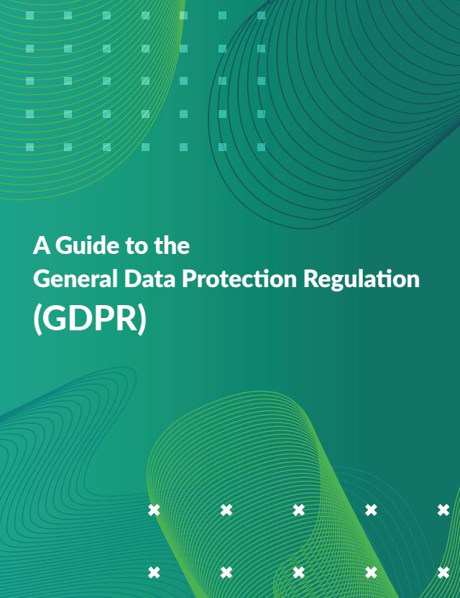

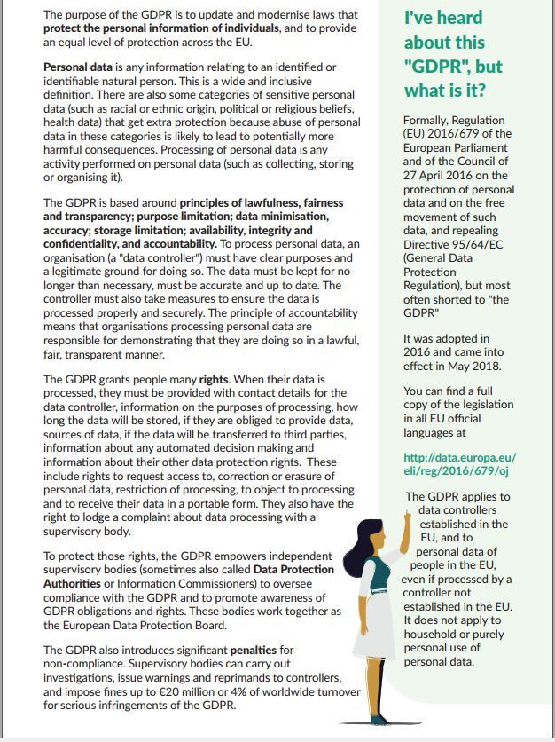

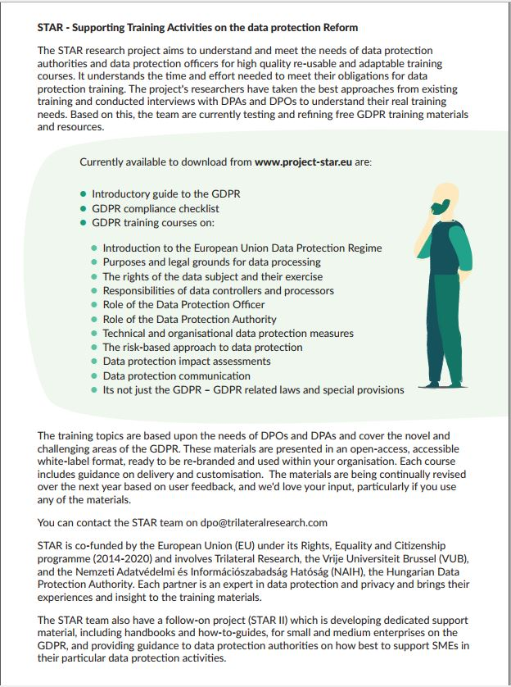

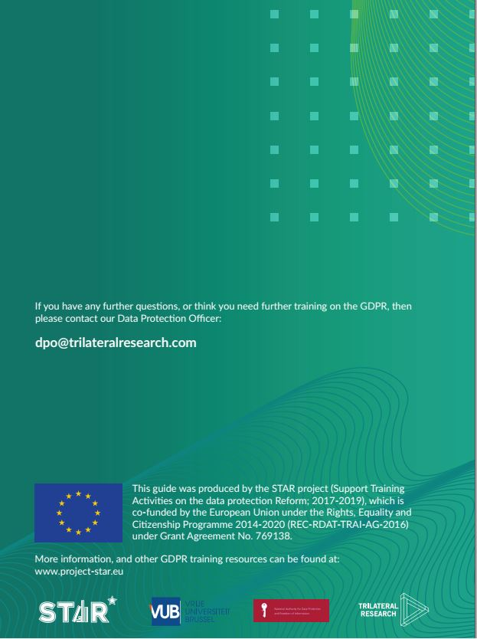

## Press releases

To further spread information on the outcomes STAR project NAIH prepared three press releases on the actual status of the project. The press releases were published on the NAIH’s website, which was considered the most appropriate informational platform for the stakeholders of the project as the end-users presumably used to visit the NAIH website for information on recent data protection issues, guidelines and decisions issued by the authority and other information on the activity of the authority.

The first one was published on 27.11.2017 announcing the launch of the project, the second one in October 2019 when the draft training materials were drawn and the last one in November 2019 on the results of the project.

The full text of the press releases is reported in deliverable D5.3 Press releases.

## Journal article

An academic journal article was prepared by the authors based upon the research conducted within the STAR project – in particular the stakeholder consultation, requirements gathering and best practice identification work conducted in WP2.

At the time of submission of this deliverable, the article has been submitted for review at Computer Law and Security Review (CLSR). Academic journals can have long lead-in times to publication. The authors commit to making any required changes to the article for publication in CLSR, or if unsuccessful, to finding an alternative venue of comparable quality and visibility.

The journal article is reported in deliverable D5.2 Journal articles.

## Trade press articles

To further spread information on the STAR project two trade press articles were published at the end of the project. The English language version was published in English in the print and digital versions of Issue 161, Privacy Laws & Business, in October 2019. PL&B is one of world’s longest established and most valued publications on data protection/privacy law. On 15th October 2019, the article was republished in the news section of Trilateral Research’s website. <https://trilateralresearch.co.uk/star-research-project-launches-free-and-open-gdpr-training-materials/>

This article was also included in Trilateral’s October newsletter, reaching out to more than 2150 contacts, and promoted on Trilateral’s social media (currently 2290 Twitter contacts and 4700 LinkedIN contacts currently).

The Hungarian language version of the article was submitted for review to Information Society, an academic journal dedicated to information society. The journal is published four times a year. The journal is included in the Citation Index of the Web of Science Social Sciences and in the Scopus database. Records of published papers are automatically added to the Crossref database and the Library of Hungarian Scientific Works, while the full text of the papers is archived in the REAL repository.

The article was also circulated in the newsletter of the Hungarian Chamber of Commerce and Industry to reach out to all members of the Chamber including DPOs and other possible end-users of the training materials.

The Hungarian translation was also published on NAIH’s website on 07.11.2019 and is available at the following link: <https://www.naih.hu/files/Trade-press-article_HU_v2.pdf>.

The trade press articles are reported in deliverable D5.4 Trade press articles.

# Dissemination tools to distribute the training materials

## Participation in conferences and events

Apart from the project website, participation in conferences and events are the most efficient tool for the dissemination of the project since a significant number of stakeholders can be reached at the same time. Besides in view of the nature of the main output of the STAR project a personal dissemination of the training materials seemed to be the most effective way to gather feedback on the training materials from the end-users.

The events presented in section 3.1.1 and 3.1.2 introduced and discussed the final results of the STAR project. These panels identified the challenges and best practices around data protection training, then launched the ready-made, easy-to-customise and easy-to-run training materials, (i.e. 11 Microsoft PowerPoint presentations, training scenarios, further supporting forms as well as a handbook for trainers and users of the materials) targeted for DPAs and DPOs. During the event speakers guided the audience through the STAR materials and, in form of a discussion, gathered their feedback and experience from training activities thereafter.

### Support training activities on the data protection reform (STAR) - Final conference

The results of the STAR project were presented on 17 October 2019 in Brussels, Belgium. This event was dedicated specifically to DPOs. The details of the event can be found at the following link: <https://brusselsprivacyhub.eu/events/17102019.html>

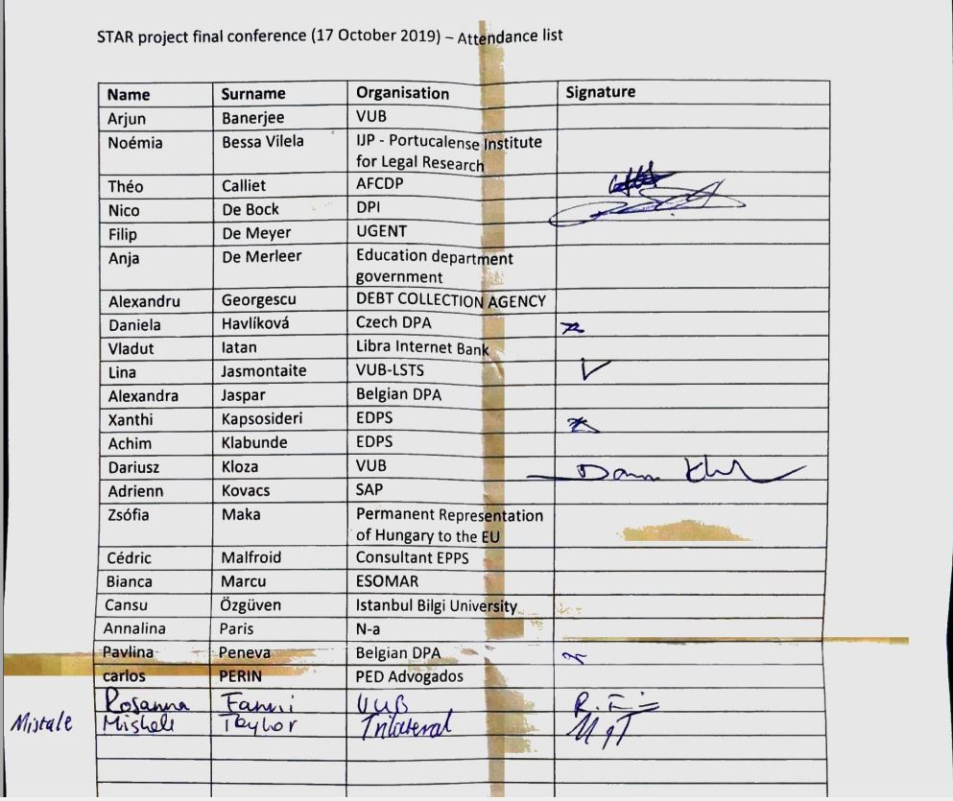

### 41th International Conference of Data Protection and Privacy Commissioners

The results of the STAR project were also presented on 22 October 2019 in Tirana, Albania on the Side Event of the International Conference of Data Protection and Privacy Commissioners. This event was dedicated specifically to representatives of DPAs. The details of the event can be found at the following link: <https://privacyconference2019.info/conference/side-events/>

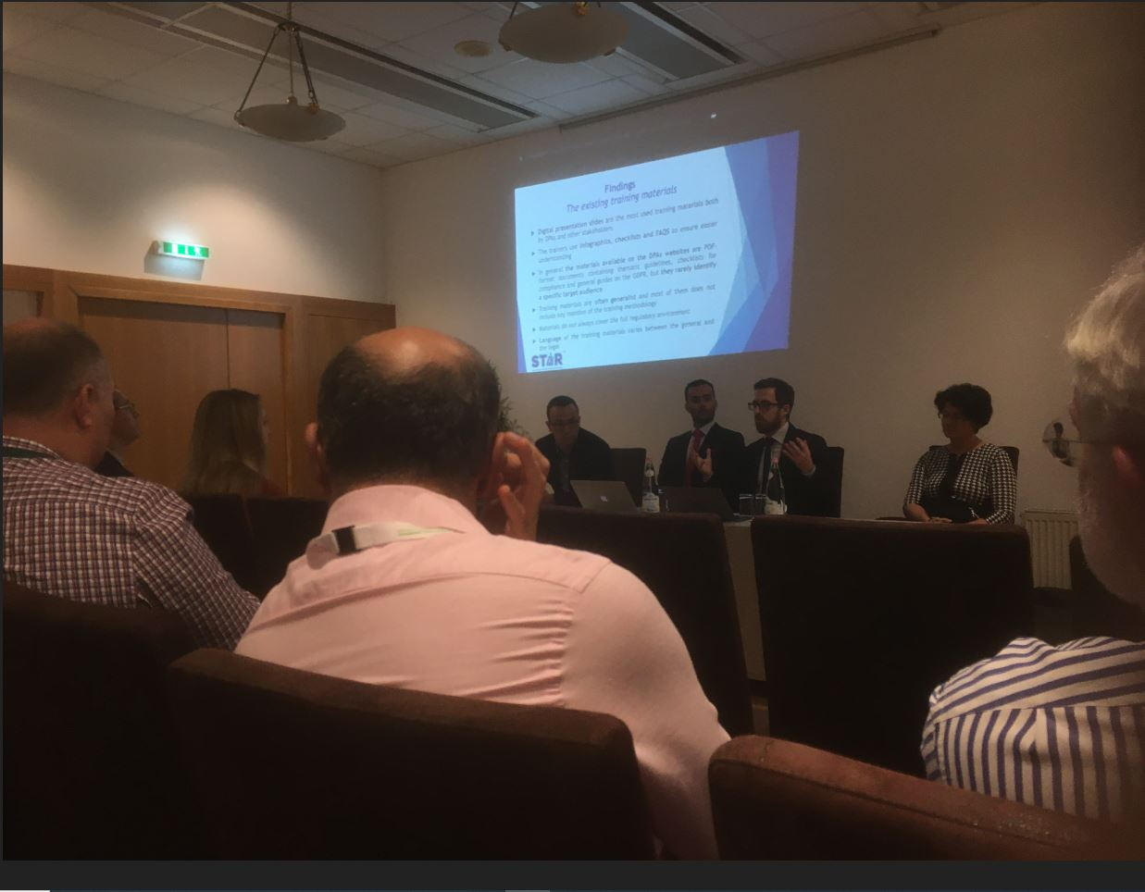

### ICO Data Protection Practitioners Conference

TRI had an exhibition at the ICO Data Protection Practitioners Conference[1] held on 8 April 2019 which offered the opportunity to showcase STAR training materials to around 900 attendees who are all data protection practitioners, the stakeholders targeted by the STAR materials. The training materials were displayed on a laptop on an exhibition stand. At this event we also had available printed copies of the two-page guide to the GDPR developed as part of the STAR training materials, that attendees could take away with them. A highlight of the day was Elizabeth Denham, the UK’s Information Commissioner, visiting the stand in person.

Organisations that expressed an interest in STAR included North West Ambulance Service and Countrywide PLC. Some considerations for the STAR that emerged from the event:

* The main obstacles appeared to be that individuals already had their core data protection materials covered but were looking for new and innovative ways to deliver them.
* TRI were asked for ‘fun interactive eLearning’ three times and a stand that had this (featuring a GDPR game) was very busy.
* Looking to the future it would be beneficial to have the core materials, some videos and some eLearning modules to show.
* Individuals are keen to gain continuing professional development (CPD) points and credentials from training.



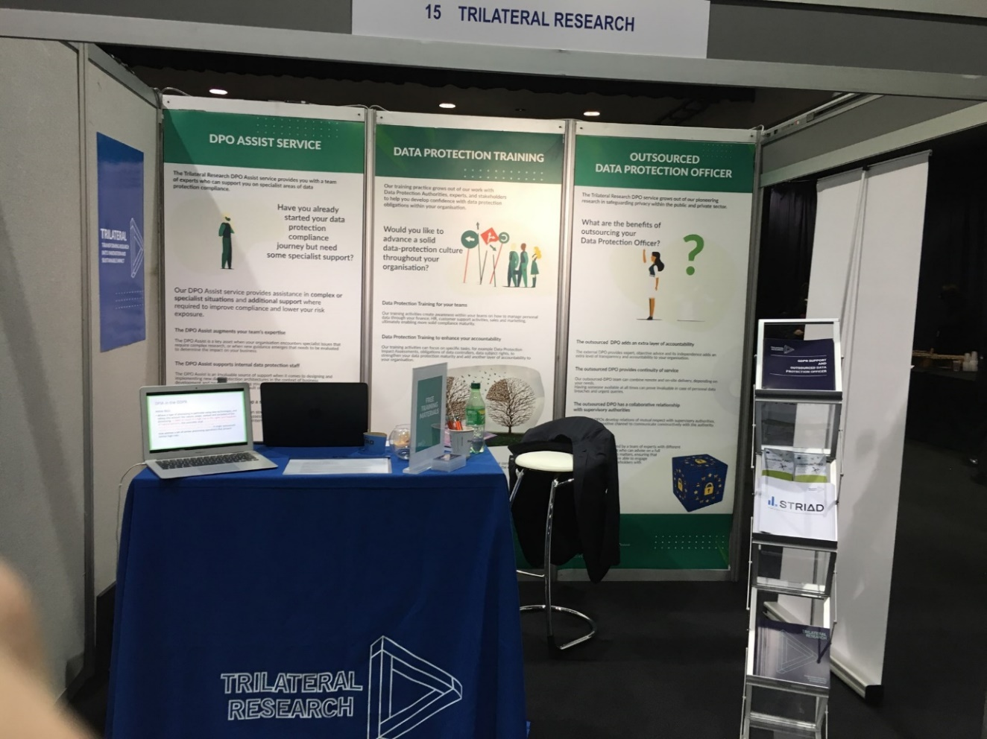

## Communication with stakeholders

The STAR consortium interacted with stakeholders (DPAs and DPOs) throughout the project’s two-year term mainly through, e-mails in order to ensure that potential end-users are aware and up-to-date with regard to training materials developed under STAR. A key part of this activity was recruiting DPAs who may be willing to commit to trailing the training materials with STAR in WP4.

The training materials have been circulated among EU DPAs and selected DPOs, their representative organisations, with a view of their validation. This has been performed by means of an accompanying web-based questionnaire, that all of these stakeholders were invited to reply. Our intention was to use their feedback to finalise the training materials, but as unfortunately only a few replies have been received, we contacted the stakeholders repeatedly via e-mail asking them to use or at least to go through the STAR materials and to share their opinion, ideas, suggestions with us, either by filling the questionnaire or simply via e-mail (see section 5 of deliverable D5.1 STAR online communication tools).

Despite our efforts, we did not get too much feedback, so as one of our last resorts we also tried to gather some feedback at both final events of the project. Luckily, the attendees showed great interest, asked questions and we received a few written feedbacks from them.

STAR sent email invitations to its contact list, including the DPAs and DPOs who had participated in our interviews, as well as to individual contacts, inviting them to webinars on the STAR training materials. A social media announcement about the webinar was also posted in October 2019. Unfortunately, we received no interest in the webinar, so were unable to proceed. To replace the webinar, STAR has developed three videos to be posted online. Using a video should allow potential users of the training materials to access this in their own time, and be a more permanent resource from the project. Further information on the webinars can be found in deliverable D5.6 Webinars (and online video).

1. https://ico.org.uk/global/data-protection-practitioners-conference-2019/