Table of Contents
Introduction 2
1. Hotline / helpdesk service 2
1.1 Management of the hotline/helpdesk 3
Setting up a Knowledge Base – The NAIH experience 3
1.2 Evaluation and statistics 4
2. Website 6
3. Media awareness raising methods 7
4. Face to face meetings 9

Introduction

Financed by the European Union, the STAR II (SupporT small And medium enterprises on the data protection Reform II) project, running in the partnership of the National Authority for Data Protection and Freedom of Information (NAIH), the Research Group on Law, Science, Technology & Society (LSTS) of the Vrije Universiteit Brussel (VUB), and the Trilateral Research Limited (TRI IE) between 2018 and 2020, has the aim of assisting SMEs in applying the GDPR.

Taking the structure and needs of SMEs into account, the project helps the enterprises in question shape an appropriate practice.

In the course of the project, partners surveyed how the EU data protection authorities call, and have called, the attention of SMEs to their obligations arising from the GDPR, and also gathered information on the experience gained by SMEs in applying the GDPR.

In this document, based on the knowledge gained through the project’s main activities (most notably, the information gathering process, the awareness-raising campaign and the running of the hotline) and the interaction with DPAs and SMEs throughout the project, the consortium tries to give a guidance for DPAs on good practices in raising awareness, especially of SMEs about GDPR issues.

Hotline / helpdesk service

A helpdesk or hotline service can be a very useful tool for DPAs to establish connection between the DPA and the general public including the data subjects and SMEs. The interested parties are provided a continuously available source of up to date and trustworthy information. However a telephone hotline/helpdesk is not an adequate platform to give legal advice in a specific issue due to liability issues as well as operating an e-mail hotline/helpdesk service can also face the issue of liability, therefore DPAs tend to give general guidance on the data protection legislation.

The interviews carried out with DPAs by the Consortium on their awareness-raising activities among SMEs about the GDPR concluded that all DPAs operated a form of telephone or email and telephone advice service SMEs can use to contact the DPA, however in most cases, this service was not an SME specific hotline/helpdesk service.

Most DPAs do not use internal guidance to direct hotline/helpdesk advisers. Just over a quarter of DPAs did. Most calls/queries were facilitated in the national language of the respective country which was also the language in greatest demand from SMEs. While English was also widely facilitated across the EU DPAs, a small number of DPAs expressed that it would be beneficial to develop their English language capacity.

In order to ensure compliance with the GDPR and gather valuable information about the difficulties they face, NAIH is operating a hotline for SMEs between 15 March 2019 and 15 March 2020 to assist them in the compliance with the GDPR. In this period NAIH provides information for SMEs throughout the European Union in respect of the interpretation and proper application of the GDPR.

Setting up the SME hotline – The NAIH experience
Based on the experiences of the NAIH on the SME hotline we identified the following best practices on how to set up and run a hotline (with special attention to the required infrastructure, resources required, engaged personnel, internal policies, legal implications and ethical considerations).

The SME hotline is maintained at NAIH premises, infrastructure (office, web interface, etc.) and necessary workforce (hotline administrator, hotline expert, DP experts, professional supervisor) is provided by NAIH. The “Knowledge Base” has been created before the trial-hotline started its operation, but it is constantly expanding based on the incoming questions and the answers given to them.

A data protection notice and internal rules for the operation of the hotline (including deadlines, conditions of assistance, liability issues) have also been prepared. The Partners also set the platforms of communication (primarily e-mail; availability of other means to be further explored); and to gather feedback from the SMEs via satisfaction surveys.

The internal rules for the operation (Memorandum) of the hotline lay down the tasks of the engaged personnel, the internal policies (including deadlines, conditions of assistance, languages used, etc.) and it covers liability issues as well.

The Memorandum also laid down the detailed rules for the responses given. The responses shall be formulated so as to not only include the mere repetition of the provisions of law, but also to provide graspable assistance in the interpretation of law applicable relevant to the merit of the question, and to highlight the relevant aspects in the application of law related to the given question, the factors to be considered among them, and their significance. The answer shall contain no opinion as to the lawfulness of any concrete data processing.

1.1 Management of the hotline/helpdesk

The use of internal guidance to direct hotline/helpdesk advisers can be a good practice to be followed in order to treat liability issues.

The responses given help to explain to SMEs the basics of data protection law and the GDPR. The responses shall be formulated so as to not only include the mere repetition of the provisions of law, but also to provide graspable assistance in the interpretation of law applicable relevant to the merit of the question, and to highlight the relevant aspects in the application of law related to the given question, the factors to be considered among them, and their significance. The answer shall contain no opinion as to the lawfulness of any concrete data processing. Particularly complex cases are guided towards the respective competent DPA for resolution.

Setting up a Knowledge Base – The NAIH experience
To support the fulfilment of the SME hotline task the NAIH developed a Knowledge Base on the basis of the law-enforcement practice of the Authority and the documents of the European Data Protection Board assisting the application of law by colleagues operating the SME hotline. The Knowledge Base has a question–and–answer structure, and contains abridgments of law-enforcement practice in pairs of questions and answers, providing relevant citations and keywords to assist searches. The Knowledge Base shall be updated at least on a monthly basis.

Evaluation and statistics

The functioning of the SME hotline, the issues faced and questions answered needs to be continuously monitored (qualitatively and quantitatively). Based on the statistical analysis, the functioning of the hotline can be periodically refined and adjusted to the needs. The statistical analysis will also serve as necessary data for the monitoring and evaluation of SME awareness-raising strategies and the success of any knowledge-based resources as well.

In order to collect the necessary information for a statistical analysis a Register of all hotline requests and the responses to them with specified content is to be maintained.

The data obtained from the Register is a source of information about the needs and difficulties SMEs are facing in compliance with the GDPR. Based on the Register the most frequently asked questions can be tracked, which is an important indicator of SME concerns and apprehensions about the GDPR. Based on the statistical analysis, the functioning of the hotline is periodically refined and adjusted to the needs of SMEs. The statistical analysis of the data collected in the Register also enables the DPAs to identify the most compelling needs of the SMEs in their compliance and also the assessment of the issues that need to be clarified.

The aforesaid fosters the development of the informational strategies that meet the needs of the SMEs most. The statistical data analysis of the hotline can facilitate the customization of the DPA’s training program and to monitor changes in SME concerns/queries over time.

Register - The NAIH experience
The aim of the Register is to monitor the timely response to requests received and to collect statistical data needed for other products of the Project. The Register includes the e-mail address of the requester as personal data only in order to monitor the fulfilment of the request, and the personal data required for other products by the Project shall be deleted when the SME hotline task is concluded.

Statistical data – The NAIH experience
The NAIH has experienced a relatively high interest among SMEs during the hotline’s operation, but it must be noted that only Hungarian SMEs have used the hotline so far.

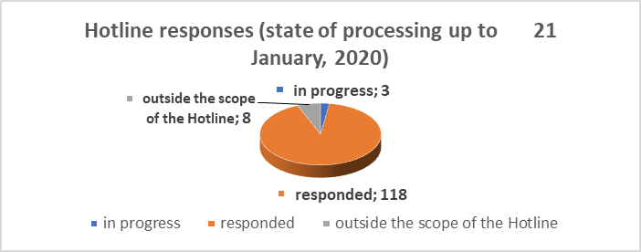

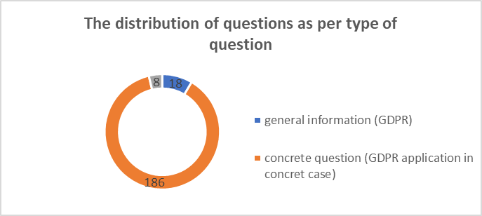

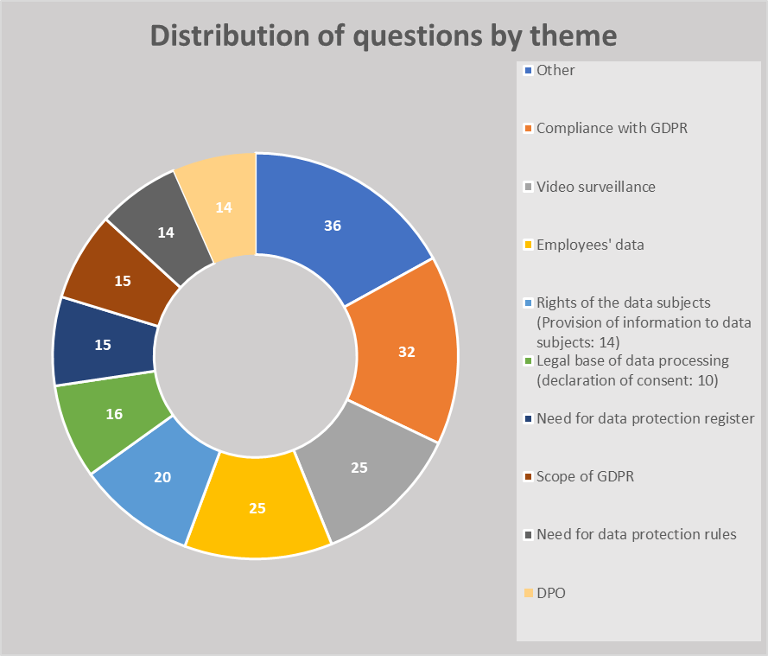

Website

One of the most effective platforms available for DPAs to spread information is their own website, which is the most appropriate informational platform for the addresses of the information provided by the supervisory authorities on data protection issues as they presumably used to visit the DPAs’ website for information on recent data protection issues, guidelines and decisions issued by the authority and any other information on the activity of the authority. Therefore, we foster the DPAs to share information on data protection, decisions and opinions issued by the DPA, guidelines, practical examples, etc. on their website. The information to be provided must be as practical as possible, as especially SMEs are interested in detailed practical information. This could be done in coordination with SME associations to avoid duplication of effort and maximise resources. The emphasis here is again on follow-up and mapping change.

Decisions and opinions
The NAIH regularly publishes final decisions and opinions on its website. The database is freely available for the public and it is regularly updated with the latest documents issued by the authority. All available decisions, opinions and recommendations can be searched by topic.

Hotline FAQs
Besides all relevant up to date information on the activity of the authority, the website also offers special information for data controllers and data processors to assist them is compliance with the GDPR. A 12 point introductory guidance can be found at the following link:
https://naih.hu/felkeszueles-az-adatvedelmi-rendelet-alkalmazasara.html
The website also provides information to SMEs on the GDPR compliance, a short information booklet is provided on a regular basis.

Press releases
To further spread information on the outcomes STAR II and especially on the operation of an SME hotline the NAIH prepared press releases on the actual status of the project. The press releases were published on the NAIH’s website, which was considered the most appropriate informational platform for the stakeholders of the project as the end-users presumably used to visit the NAIH website for information on recent data protection issues, guidelines and decisions issued by the authority and other information on the activity of the authority.

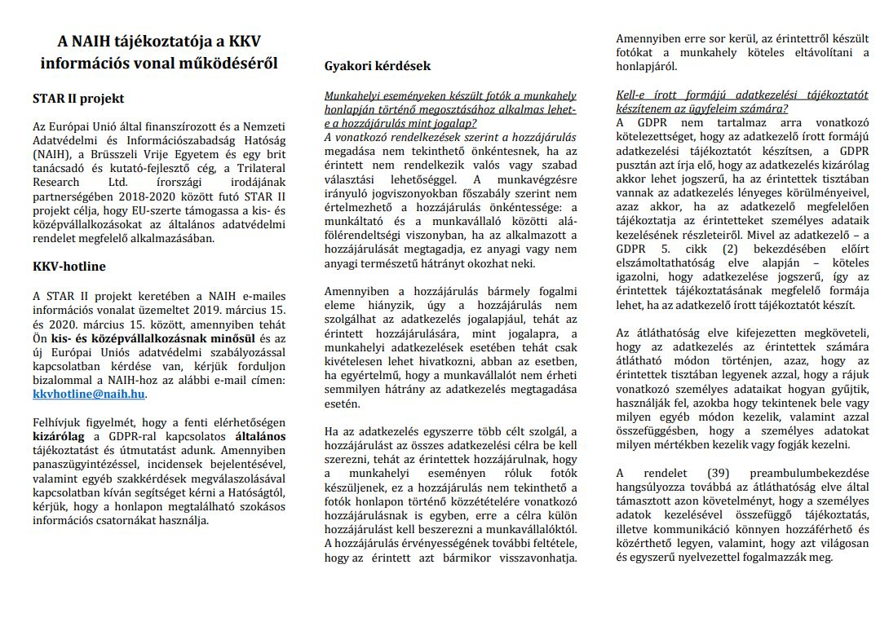

Media awareness raising methods

DPAs identified the print media, social media and events as the most common general awareness-raising methods when asked. Although the multi-method approach came out strongest, of the specific methods identified, DPAs referred to events as the most effective awareness-raising strategy for SMEs.

The majority of the SMEs contacting NAIH refers to the information available on the website of NAIH, a smaller part refers to the radio campaign. Based on the increased interest of the SMEs on their GDPR compliance, the awareness raising campaign has successfully reached its goal.

Radio campaign - The NAIH experience

The campaign aimed to reach out to SMEs to raise their awareness regarding the GDPR and to draw more attention to the new regulatory framework on personal data protection. The campaign also explained the particular forms of assistance STAR II will provide, namely the hotline for SMEs in the first place, and – subsequently – the handbook for SMEs and a guidance for DPAs. The campaign reached out the target group widely and has risen the awareness of the SMEs in Hungary about the need to comply with the new data protection framework and encouraged them to take the necessary measures.

The communication channel (radio), the length of the campaign (one month), the frequency of broadcasting (two plus one spots per day) were based on the experience gained in the ARCADES project. A one-month-long campaign with three spots (50 seconds) per day was deemed to be appropriate to deliver the message for a significant number of people, including the target audience.

NAIH requested quotes from the Hungarian Media Service Support and Trust Fund (MTVA) on the expected costs of the recording and one-month-long broadcast, and later a contract has been signed.

NAIH drafted the text and the scenarios of the radio campaign in English and in Hungarian and then validated them with the consortium. The final text and the scenarios of the radio spot was recorded in Hungarian language on 20.12.2018. The following text was recorded:

“Do you know that small and medium-sized enterprises represent 99% of all businesses in the EU? Rules and obligations of the new EU data protection regulation (coming into force as of May 2018) affect generally these data controllers, too and there are also some specific rules of the GDPR which apply to SMEs. For more information please, contact the National Authority for Data Protection and Freedom of Information, which has set up a special hotline: kkvhotline@naih.hu. This PSA has been prepared upon the request of NAIH and co-financed by the Rights, Equality and Citizenship Programme of the European Union under the supervision of the DG JUST of the Commission.”

The radio campaign was broadcasted by Petőfi Rádió, a countrywide available public radio that has the most listeners per day among the entire adult population in Hungary. According to the data published by the National Media and Infocommunications Authority, Petőfi Rádió has had about 1,3 million listeners per day in average in the first quarter of 2019. The radio spot was broadcasted 86 times between 15.03.2019 – 15.04.2019 (17 times in the morning hours, 37 times in the afternoon hours and 32 times in the evening hours).

Face to face meetings

As reported in Deliverable D2.1 - Report on DPA efforts to raise awareness among SMEs on the GDPR DPAs pointed to a variety of other ways in which they became aware of the needs of SMEs concerning the GDPR. While consultation feedback provided by SME representative bodies was mentioned, it appeared that the one-to-one interaction that a DPA has with individual SME representatives in a consultation or advisory context provided DPAs with the most substantial benefit in terms of understanding the needs of SMEs. Such interactions occur through established engagement channels such as the public-facing hotline or helpdesk service, participation and presentations at events organised by third parties or other consultation and advisory services. In these contexts, individual SMEs were approaching DPAs with very practical questions that required specific answers. Individual comments made by various DPAs which appear more context specific also help to highlight some other ways in which DPAs can engage at a personal level with SMEs.
Dublin workshop
A validation workshop for the preliminary results of the STAR II research project, was held in Dublin in June 2019. The report on the first validation workshop can be found in Deliverable D2.3 Report on WP2 Validation workshop.

The Somogy Chamber of Commerce and Industry
The Somogy Chamber of Commerce and Industry organised an information event for SMEs on the GDPR in June 2019. The Chamber invited the representatives of the NAIH and all SMEs registered at the Chamber. The attending SMEs were provided the opportunity to ask questions they are most interested in concerning the GDPR compliance.

The Budapest Chamber of Commerce and Industry
The Budapest Chamber of Commerce and Industry organised an information event for SMEs on the GDPR in October 2019. The Chamber invited the representatives of the NAIH and all SMEs registered at the Chamber. The attending SMEs were provided the opportunity to ask questions they are most interested in concerning the GDPR compliance.

Other conferences
The President and other representatives of NAIH presented the project and the launch of the SME hotline on several conferences (Hungarian Decision maker Think Tank Conference, Infoszféra conference, Data Protection Case Handling Workshop). To further advertise the STAR II project and the SME hotline the NAIH published an announcement on its website on the launch and operation of the SME hotline on 14.03.2019.

